Supplementary material

Data collection
In order to collect relevant articles, we queried English journal articles from the Web of Science in SCI-EXPANDED, SSCI, AHCI, and ESCI, between 2005 and 2019. It is important to note that we focus specifically on research conducted on the major social media platforms worldwide, thereby excluding some nationally-based language-specific social media platforms (e.g., Weibo and VK). We retrieved a total of 12, 732 records using the following three search strings:
TS=("social media data"),
TS=("social media" OR "social network* site*" OR "online social network*" OR facebook OR twitter OR instagram OR blog OR microblog OR YouTube OR Flickr) AND TS=(tweet* OR hashtag* OR weblink* OR posting OR commenting OR "news feed" OR user profile OR geotag* OR Youtube video OR "digital data" OR "computational social" OR "digital social" or "social web data") NOT TS=(survey OR questionnaire OR interview)
TS=( facebook OR twitter OR instagram OR blog OR microblog OR YouTube OR Flickr) AND TS=(dataset).
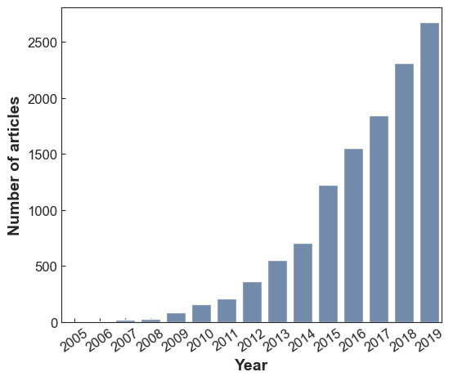
Figure S1 Number of relevant publications by year (2005-2019). From this time series graph, we can see the explosion of work using social media data since 2005.

Data annotation and Word2Vec model training
First, we annotated 200 randomly sampled articles. We did so by reading through the textual content—abstract, title, and keywords—and identifying all the method-related terms for each article. We then scraped and validated a list of methods from Wikipedia and another list of machine learning methods from Paperswithcode. After getting a relatively comprehensive list of 194 methods (see Table S1 in the Supplementary material), we trained our domain-specific word embeddings. Here are the procedures in detail:
At first, we applied a range of standard pre-processing techniques. We started by removing records that do not have abstracts. We then used the regular expression to remove content captured by the WoS database that is not part of the abstracts, such as copyright information. Next, we wrote abstracts, titles, and keywords together for each article, and we normalized words to lowercase and normalized the differences between UK and US spellings. We then used the linguistic technique of lemmatization on all texts to decrease the morphological variability. We used a language processing pipeline with the Spacy Python package (https://spacy.io/usage/processing-pipelines), incorporating our custom tokenizer and lemmatizer. Finally, we removed stop words (e.g., the or which) in the texts.
Next, we identified common phrases such that terms content and analysis would result in a phrase content-analysis. We created the word collocation with the Gensim Python package (https://radimrehurek.com/gensim/models/phrases.html), with a minimum co-occurrence of 10 and a score threshold of 15 (Mikolov, Sutskever, et al., 2013). Besides, we improved the collocation results based on method-related phrases in our manually validated list. Our pre-processing results in 59,086 different tokens and a cumulative count of 1,446,180 tokens within all 11,909 texts.
After building the phrase-based training corpus, we used the Word2Vec Skip-gram implementation in Genism (https://radimrehurek.com/gensim/models/word2vec.html), with a window size of 5, producing a vector dimension of 300 (Mikolov et al., 2013). To ensure the robustness of our findings, we also replicated our analysis using dimensions of 50, 100, and 200. We found that core findings (e.g., Figures 6&7) were consistent with our results using a dimension size of 300. Additionally, we provided an interactive graph for the 2-d projection of embedding space, with all terms that occurred more than ten times in the corpus (see https://yangliuf95.github.io).

Table S1. Method list
Complete list of method-level terms retained in the analysis | active-learning, analysis-variance, anova, autoencoder, bayesian, case-study, categorisation, cda, chi-square, classification, clinical-trial, cluster, cnn, cohort-study, comparative-analysis, complex-network, conditional-random-field, content-analysis, content-textual-analysis, conversation-analysis, correlation, crawling, critical-genre-analysis, deep-belief-network, deep-learning, dependency-analysis, difference-in-difference, dimension-reduction, discourse-analysis, dynamic-analysis, embedding, ensemble, estimation-method, ethnographic, ethnography, experiment, exploratory-study, factor-analysis, fieldwork, fully-convolutional-network, graph-analysis, graph-convolutional-network, graphical-model, ground-theory, hybrid-learning, hypothesis-test, image-representation-matching-approach, incremental-learning, intention-to-treat-analysis, interview, keyword-analysis, knowledge-based-method, lexicon-based-approach, linguistic-analysis, literature-analysis, manual-coding, manual-review, micro-analysis, mining, monte-carlo-method, natural-language-processing, netnographic, netnography, network-analysis, network-model, neural-network, nlp, normality-test, observational, pilot-study, polling, pre-processing, prediction, predictive-analytic, predictive-model, pre-processing, questionnaire, randomize-trial, randomized-control, regression, residual-network, rnn, self-learning, sensitivity-analysis, sequential-analysis, siamese-network, sna, social-interaction-network, spatial-analysis, spatio-textual, static-analysis, structural-approach, support-vector-machine, survey, survival-analysis, svm, systematic-review, t-test, text-analysis, text-analytic, thematic-analysis, time-sequence-analysis, time-series-analysis, topic-model, transfer-learning, trend-analysis
Original method list (based on manual labeling and web mining) | active-learning, analysis-variance, anova, audiovisual-approach, autoencoder, auxiliary-classifier, bags-of-word, bayesian-statistic, bert, bidirectional-lstm, big-data-analysis, case-study, causal-inference, change-detection, class-activation-map, classification, clinical-trial, cluster, cluster-algorithm, cluster-analysis, cohort-study, complex-network, conditional-random-field, content-analysis, content-textual-analysis, conversation-analysis, convolutional-neural-network, correlation, critical-discourse-analysis, critical-genre-analysis, data-fusion-framework, data-mining, dbscan, decision-tree, deep-belief-network, deep-boltzmann-machine, deep-learning, deep-neural-network, deep-q-network, deepwalk, dependency-analysis, descriptive-statistic, detection, detrende-correspondence-analysis, discourse-analysis, discrete-cosine-transform, dynamic-analysis, dynamic-linear-model, dynamic-network, dynamic-programming, dynamic-time-warping, ego-centric-network, elmo, ensemble-clustering, ensemble-learning, estimation-density, estimation-method, ethnography, ethnomethodology, ethonography, experiment, experimental-study, factor-analysis, fasttext, field-experiment, fully-convolutional-network, gaussian-process, genetic-algorithms, geographical-analysis, geospatial-analysis, graph-analysis, graph-based-optimization, graph-convolutional-network, hashtag-extraction, hybrid-learning, image-representation-matching-approach, information-retrieval, intention-to-treat-analysis, k-means-cluster, k-nearest-neighbor, keyword-analysis, knn, knowledge-based-method, laplacian-eigenmap, latent-dirichlet-allocation, lda, linear-discriminant-analysis, linear-regression, linguistic-analysis, literature-analysis, logistic-regression, long-short-term-memory, machine-learning, manual-review, markov-network, markov-random-field, matrix-factorization, maximum-entropy, maximum-likelihood-estimation, memory-network, metaheuristic-algorithm, metropolis-hastings, mixed-method, moderation-analysis, monte-carlo-method, multivariate-regression, multivariate-statistic, naive-bayesian, natural-language-processing, netnographic-analysis, netnography, network-analysis, network-model, neural-network, nlp, node2vec, normality-test, observational-study, online-research-method, part-of-speech-tagging, peak-analysis, polarity-analysis, predictive-model, qualitative, qualitative-analysis, qualitative-content-analysis, qualitative-data-analysis, qualitative-research, quantitative, quantitative-analysis, quantitative-model, quantitative-statistical, quasi-experiment, questionnaire, random-forest, random-search, randomize-trial, rank-algorithm, region-proposal-network, regression, residual-network, restricted-boltzmann-machine, retweet-network-analysis, robust-statistic, sample, sample-statistic, selection-model, self-organize-map, semantic-network-analysis, semi-supervised-learning, sensitivity-analysis, sentiment-analysis, sentiment-classifier, sequence-sequence, sequential-analysis, sequential-method, siamese-network, social-interaction-network, social-network, social-network-analysis, social-network-mining, spatial-analysis, spatial-clustering, spectral-clustering, static-analysis, statistical, statistical-analysis, statistical-inference, statistical-model, statistical-test, stochastic-topic-block, structural-approach, supervise-text-classification, support-vector-machine, survey, survival-analysis, synthetic-minority-over-sample-technique, systematic-review, text-analysis, text-analytic, text-mining, text-tokenization, thematic-analysis, time-sequence-analysis, time-series-analysis, topic-mining, topic-model, transformer, trend-analysis, unsupervise-machine-learning, unsupervised-graph-based-algorithm, unsupervised-learning, vgg, virtual-ethnography

Table S2. Network topological quantities for the journal citation network
Threshold | Nodes(% of the original network) | Edges(% of the original network) | Number of nodes in the giant component | Average clustering coefficient | Modularity score | Average Degree | Number of clusters
0.5 | 1552(87.2%) | 9533(84.3%) | 1547(99.7%) | 0.334 | 0.51 | 12.285 | 60

The directed journal citation network
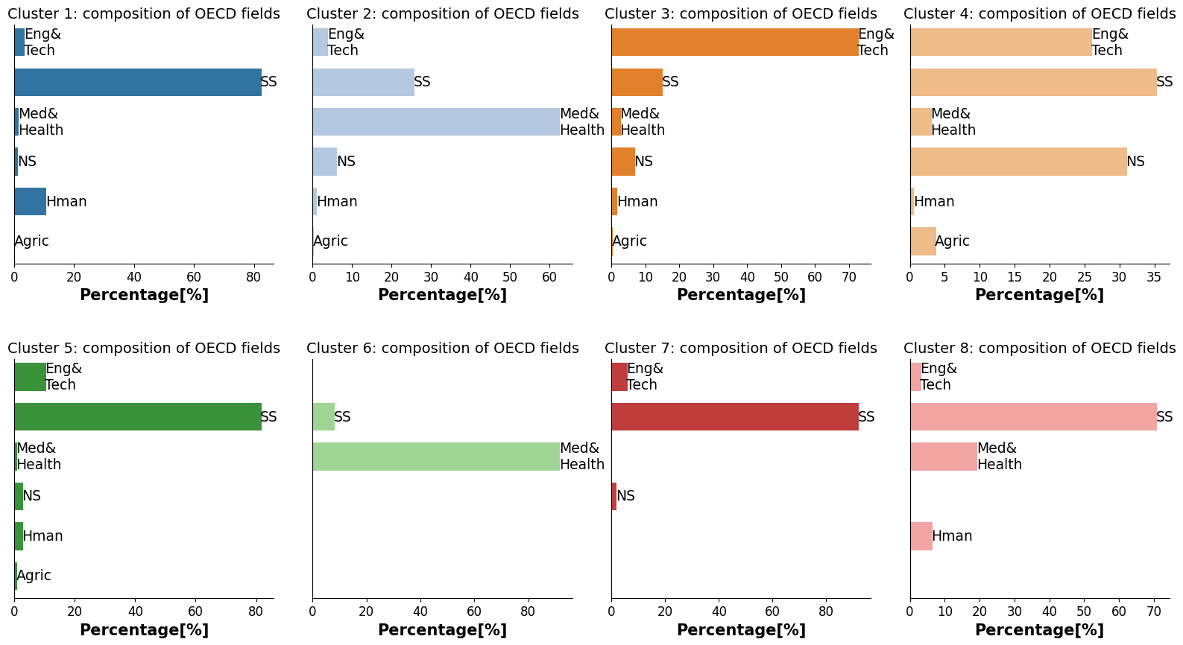
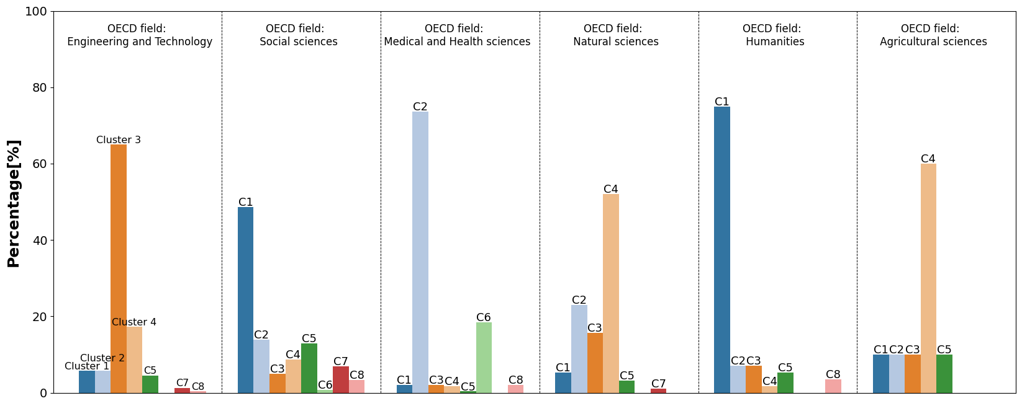
Figure S2. Proportion of periodicals in each OECD field category across network clusters.
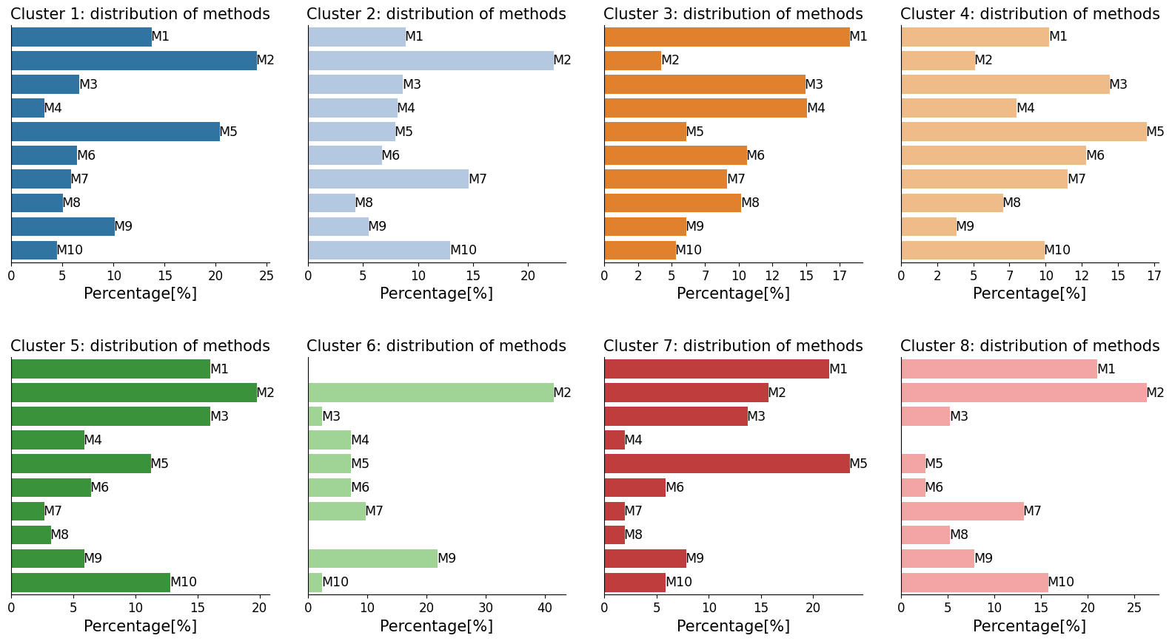
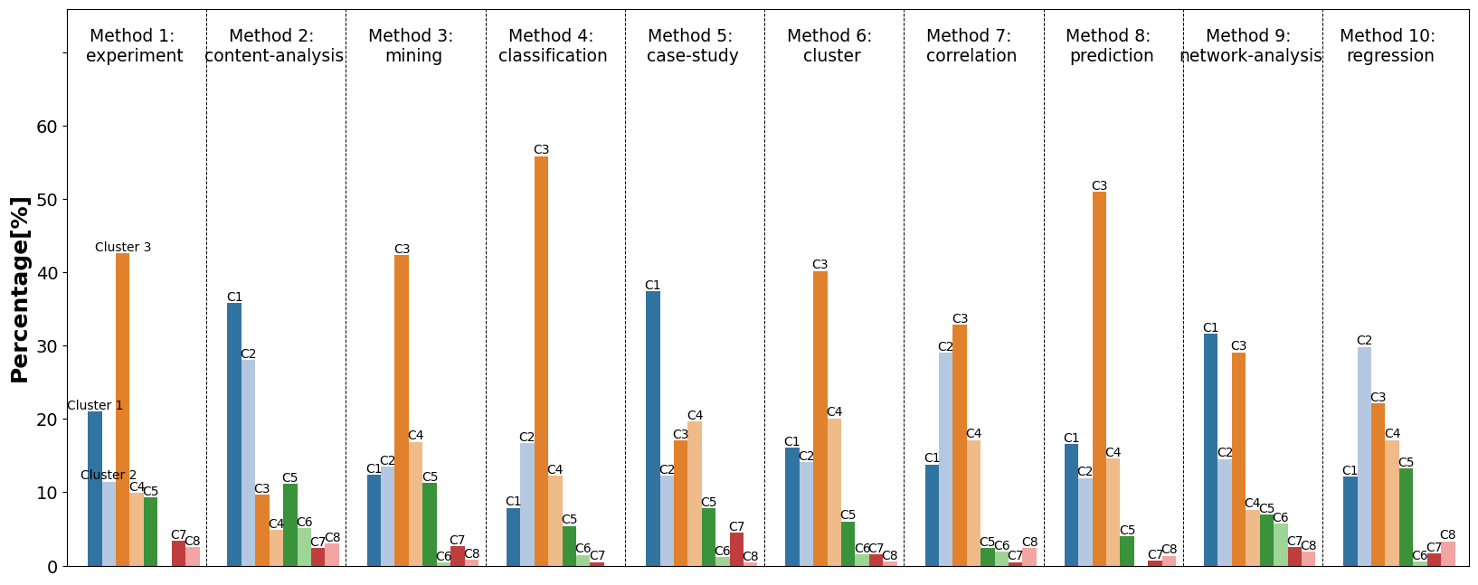
Figure S3. Proportion of periodicals using the most common methods across network clusters.

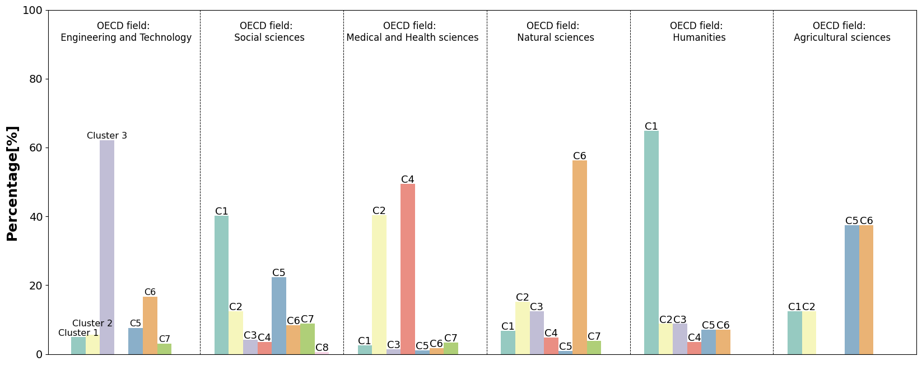
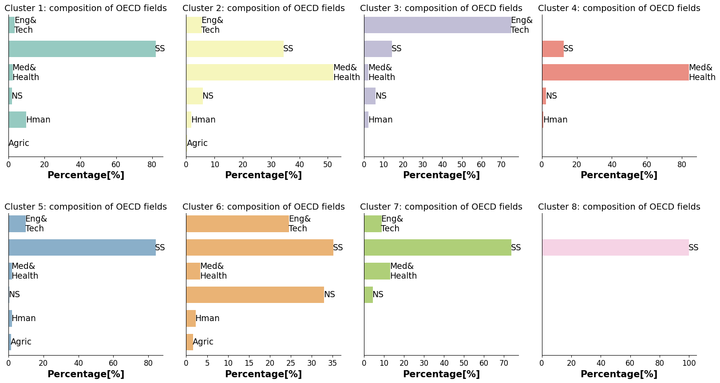
The Leiden clusters

Figure S4. Proportion of periodicals in each OECD field category across network clusters.
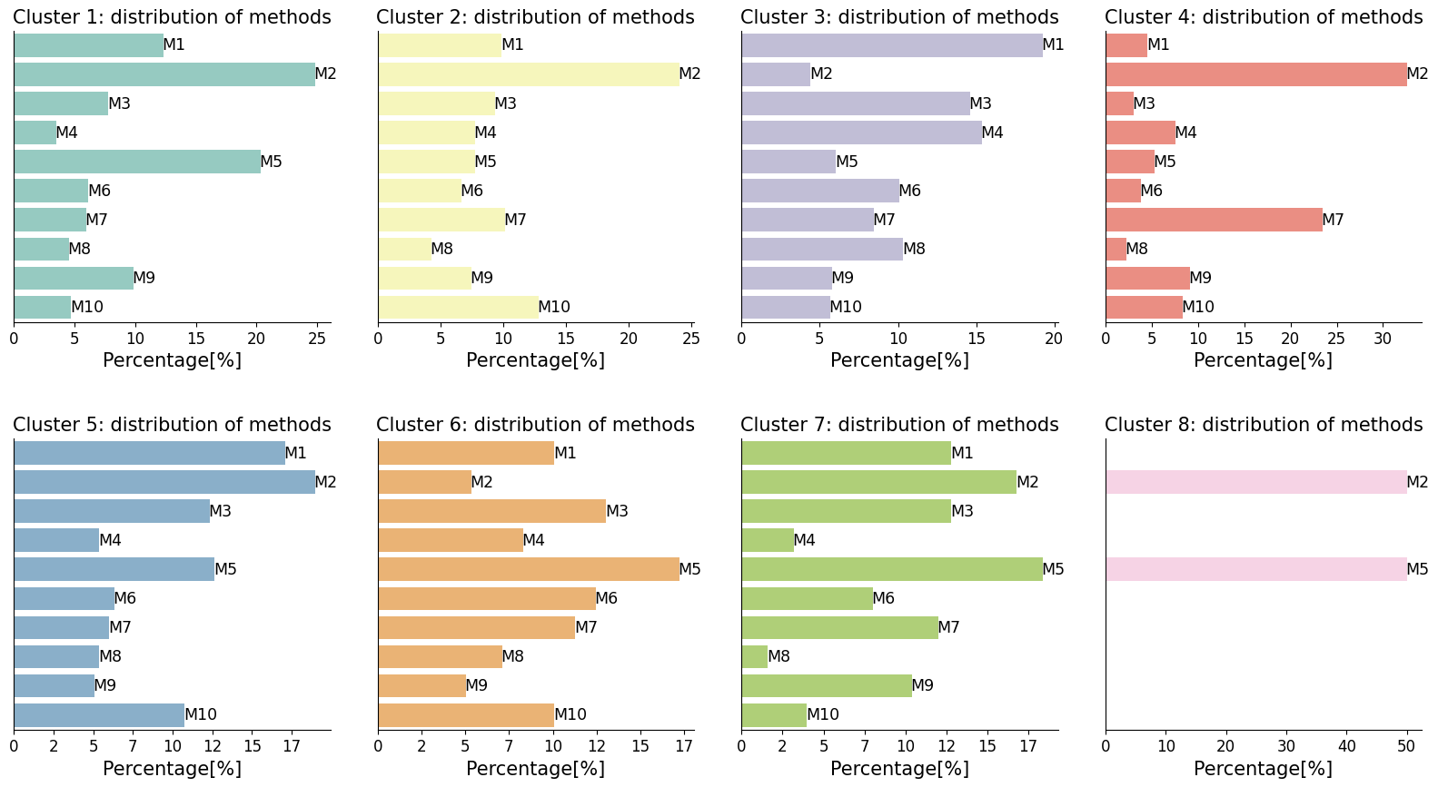
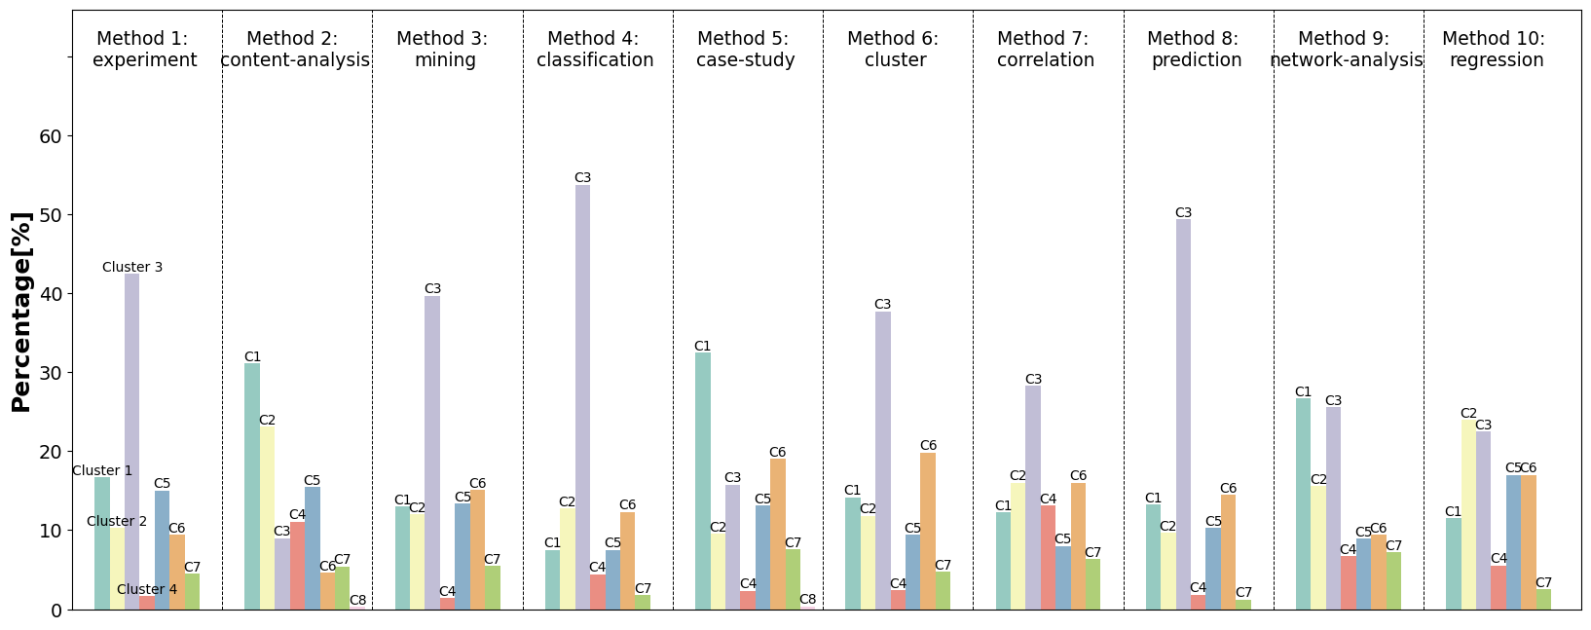
Figure S5. Proportion of periodicals using the most common methods across network clusters.

Data validity checks have confirmed that 89 out of 100 articles in our dataset have carried out research using social media data. In turn, 89 randomly found journal articles using social media data are found in our dataset.
Wikipedia record was retrieved using the MediaWiki Action API (https://en.wikipedia.org/w/api.php). Paperswithcode is an openly licensed website, which is contributed collaboratively by the community of machine learning researchers (https://paperswithcode.com).

