Appendix

Vignette 1: Private Profile

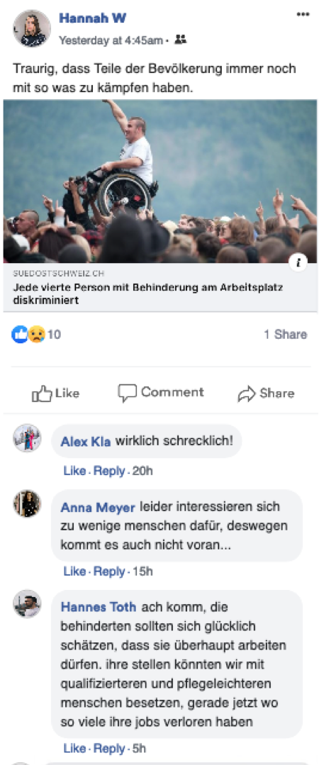 | Hannah (23), a student, recently posted an article about the discrimination of people with disabilities on the job. Three people commented on the post.  Translation:  Article title: Every fourth person with disability faces discrimination on the job  Hannah’s caption: It’s so sad that some people still have to struggle with these things.  Alex Kla: really horrible!  Anna Meyer: unfortunately few people care about this, so no wonder things aren’t getting any better...  Hannes Toth: ah come on, the disabled should consider themselves lucky that they are allowed to work at all. we could fill their positions with more qualified and easier-to-care-for people, especially now that so many have lost their jobs

Vignette 2: Public Page

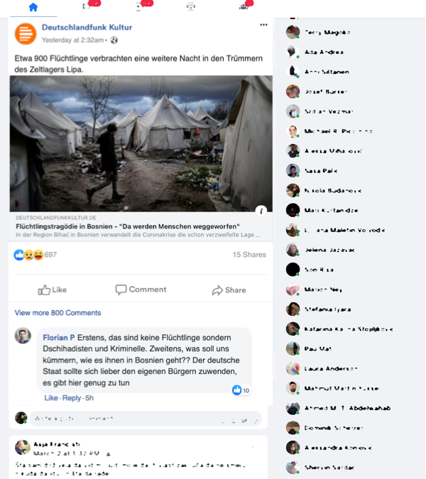 | Scrolling through his Facebook feed, Stefan (21), a student, stumbled upon a post by Deutschlandfunk Kultur about the situation in a refugee camp in Lipa in Bosnia and Herzegovina. In the comment section, he saw a comment posted by Florian P.  Translation:  Article title: Refugee tragedy in Bosnia: "People are being thrown away"  Post caption: About 900 refugees spent another night in the ruins of the Lipa tent camp.  Florian P: First, these are not refugees but jihadists and criminals. Second, why should we care how they are doing in Bosnia? The German state should rather turn to its own citizens. There is enough to do here.

