Supplemental Material

A.1 STM results
For topic area coding both the highest probability terms (Prob) and the most frequent and exclusive terms per topic (FREX) were considered. In case of ambiguous Prob terms in a topic, the FREX words were used for interpretation.
Topic Area | Topic Number | Prob | FREX
Information distribution and channel advertisement | 4 | uhr demo bitt versamml kanal liv kundgeb heut polizei dr | rechtsanwaltinn mehr_ausschuss movipo_facebook dlive.tv_zwanzig.media ausschuss_wurd inhab_ralf ludwig_zwanzig fuhrt_beweisaufnahm beweisaufnahm_corona-kris corona-kris_massnahm
Information distribution and channel advertisement | 5 | berlin gern de la telegram konnt lasst teil lockdown wurd | abo_daum unterstützung_lasst partner folg_konnt partner_kanäle telegram_weitere weitere_partner paypal_kanalmitgliedschaft konnt_telegram kanäle_infowell
Information distribution and channel advertisement | 6 | berlin querdenk demo telegram twitt web michael mehr peertub ballweg | twitt_telegram web_twitt querdenkenstuttgart peertub_web querdenkenstuttgart_peertub mehr_querdenkenstuttgart tube bic_genodesutv genodesutv tag_erlebt
Information distribution and channel advertisement | 7 | ikb chat teilen folgt partn fun ikb_chat partn_ikb chat_fun info | folgt_partn teilen_folgt link_folgt mensch_massenmedi uneingeschrankt_vertrau massenmedi_uneingeschrankt beitrag_weiterleit vertrau_geeignet jemand_grupp beitrag_link
Information distribution and channel advertisement | 17 | mehr wurd neu gibt konn man telegram mensch moglich unterstutz | ersatzkanal_seit janz eug_janz aktuell_zensurwell folgend_zensurfrei seit_twitt vk_parl vk_linkedin zensurfrei_social-media-kanal zensurwell_telegram
Information distribution and channel advertisement | 19 | polizei wurd mensch mehr deutschland jetzt polit bild uns man | jetzt_zensurfrei zensurfrei_newslett wichtig_trag newslett_rechtzeit rechtzeit_vorzubau vorzubau kritisch_polizist bundessprech_kritisch bella_ciao grossdemonstration_kassel
Information distribution and channel advertisement | 20 | mensch video mehr weimar uns unabhang kanal bitt meinung beitrag | pet_web undwobistdu_wirsehenunsalleinberlin aufzug_infokanal diskussion_austauschgrupp gedenk_rechtsstaat infokanal_aufzug aufzug_diskussion folgend_telegramkanal denk_polit meinung_gesellschaft
Information distribution and channel advertisement | 25 | dliv corona t.me on liv teilen fallzahl corona_fallzahl stuttgart stream | corona_fallzahl freetruthmedia liv_streaming community_on streaming_community stuttgartgrundgesetzdemos t.me_stuttgartgrundgesetzdemos kt stream_on kt_sw
Information distribution and channel advertisement | 28 | kanal video youtub videos telegram abonni uns uns_kanal abonniert medi | medi_analys aug_medi fried_rockt rockt_kanal offiziell_fried analys_aug of_dokus ohren_musik eig_videos videos_best
Information distribution and channel advertisement | 33 | bitt wurd news youtub mehr deutschland neu dliv lockdown deutsch | profortis william_toel lancast duk_of of_lancast john_duk stgb_stgb niewiederaufmach streit_freie niewiederaufmach_lockdownfurimm
Information distribution and channel advertisement | 35 | mehr wurd telegram teil bochum neu artikel uns ideen kanal | ideen_freund querdenkenveroffentlicht telegram_ideen dav_telegram transparenzbericht rebel_gon unterstutz_ideen paypal_unterstutzerseit unterstutzerseit biolog_clem
Mobilization | 11 | deutschland uhr freiheit stuttgart art bild deutsch euch recht jetzt | cannstatt_was versammlung_wurde querdenkenangemeldet wurde_querdenkenangemeldet querdenkenangemeldet_datum art_art bild-chef regier_nein kundgeb_cannstatt miami_gianni
Mobilization | 16 | markus haintz markus_haintz nurnberg teil jetzt mensch bitt viel wurd | schul_-inn -inn_maskenpflicht grossdemonstration_nurnberg bundesweit_grossdemonstration kauth wolfgang_kauth friend_schwrzvyc xx_xx nurnberg_beginn platz_nurnberg
Mobilization | 18 | mehr mensch wurd jetzt man ihr neu hab konn geht | stadt_bonn datum_thema plz_versammlungsort lee_kay randy_lee rapbellions_mach eysell meinung_ham ham_dahint dahint_stehn
Mobilization | 21 | man mehr mensch konn euch wurd jetzt gross lass gibt | parkplatz_alte alte_turnhall turnhall_öhring bundesregier_nein schriftlich_anzeig paar_vorschlag öhring_kundgeb zahlreich_telegram-infokanal turnhall_freu aufzug_öhring
Mobilization | 26 | uhr nurnberg freiheit aufzug euch strass mensch grundrecht berlin polizei | nurnberg_strass einfach_gesund un_geimpft egal_un erinn_nurnberg uhr_nurnberg genes_einfach burg_egal kodex_versuchskaninch bühne
Mobilization | 30 | uhr rathaus to facebook gat and bill log to_facebook log_to | to_facebook log_to uhr_rathaus friend_family facebook_log facebook_to sharing_and and_connecting connecting_with start_sharing
Mobilization | 31 | uhr video polizei mehr leipzig live freiheit strass wurd neu | video_content krall markus_krall tee_et live_elijah teilen_folgen anfrag_bitt infos_et content_anfrag unterhalt_konn
Conspiracy theories | 1 | denk heut sk teil euch mich lk beleid kommentar lasst | sk lk dumm_verkauf euch_dumm frei_denk denk_lasst verkauf_lik denk_frei inzidenz-zahl inzidenz-zahl_heut
Conspiracy theories | 9 | merkel grun polit partei reset great deutschland great_reset wahl afd | grau_haar dr_schwurbel young_global satirepatz clinton_e-mail weltwirtschaftsforum_wef mensch_grau schwab_grund vergewalt_verhaftet hiv-brief
Conspiracy theories | 12 | bundestag gesetz epidem infektionsschutzgesetz lag epidem_lag national deutsch tragweit national_tragweit | or_sign log_or see_post post_photos view_see bevolker_epidem rotarier corona_stehen stehen_satanisten lions
Conspiracy theories | 13 | man mensch euch mehr mal schon gut lieb ja mich | gruss_annett netzfund_denkt freiheit_macht macht_wahr denk_informi wahr_denk ausverkauf_deutschland gleich_ziel qanon_austria antifa_frankreich
Conspiracy theories | 29 | trump wurd usa prasident bid mehr china staat wahl land | prasident_trump steht_berichterstatt mainstream_zeig verschwieg_ausgelass trump_report telegram_rt cue_trump wladimir_putin überschreit_schwellenwert komplett_trump
Conspiracy theories | 32 | mehr honkforhop wurd deutschland jetzt bitt offiziell kommt bochum davon | inbe kassel_kommt intensivbettenregist habeck_uhr davon_belegt offiziell_rki divi_intensivbettenregist gesamtzahl_intensivbett offiziell_divi person_einwohn
Covid19 (Political Discussion) | 2 | spahn jen jen_spahn wurd mensch covid mehr jetzt deutschland million | violated be_displayed of_servic telegram's it_violated channel_cant displayed_becaus telegram's_term violated_telegram's tom_stahl
Covid19 (Political Discussion) | 23 | lockdown impfpflicht merkel mehr sod ungeimpft will neu massnahm land | arbeitet_wirklich bos_widerspruch hinnimmt_arbeitet widerspruch_hinnimmt zusamm_martin wirklich_zusamm king_burgerrechtl ausgangssperr_verfassungswidr christian_solmeck corona-impfpflicht_kind
Covid19 (Political Discussion) | 24 | test zahl positiv drost pcr-test rki corona mehr pandemi deutschland | virolog_christian les_archiviert standard-abo virolog_drost arbeit_abonni coronavirus_getestet infizierte politikmagazin_pi abonni_politikmagazin pi_politik-spezial
Covid19 (Political Discussion) | 34 | mask schul kind maskenpflicht eltern trag polizei wurd attest lehr | hallmack schulerinn_schul dahlmann christian_dahlmann anhorungsbog weltbeb maskenpflicht_grundschul europ_gmbh tim_europ bankuberweis_epoch
Covid19 (Medical Discussion) | 8 | impfung impfstoff geimpft kind impf nebenwirk mensch corona-impf covid wurd | impftot todesfall_impfung tag_impfung unserem_kanal beiträge folg_unserem beiträge_folg teil_beiträge tot_impfung astrazeneca-impf
Covid19 (Medical Discussion) | 10 | wurd mensch pfiz dr man mehr impfstoff jetzt neu biontech | nurnberg_bewegt grundrecht_gesund bewegt_protestzug protestzug_grundrecht uhr_jakobsplatz wild_virus ema_european kost_technik findet_prot haushalt_abstand
Covid19 (Medical Discussion) | 14 | dr prof prof_dr bhakdi bitt med dr_med neu interview telegram | sucharit sucharit_bhakdi spendenmog helf_spendenmog dr_sucharit hilf_helf mwgfd find_klagepat klagepat_neu infos_webseit
Covid19 (Medical Discussion) | 15 | lauterbach karl kanal karl_lauterbach mehr abonni bitt video dr wurd | vivoterra schatzkamm schatzkamm_wiss vivoterra_schatzkamm abonni_spend kanalmitglied_bitcoin produktlink affiliat_produktlink produktlink_handelt handelt_affiliate-link
Covid19 (Medical Discussion) | 22 | studi wurd geimpft impfstoff mensch neu virus impfung mehr covid | news_find beitrag_interessant interessant_lass artikel_interessant beitrag_vot hilf_auswahl auswahl_interessant interessant_news vot_artikel deutsch_nimmt
Covid19 (Medical Discussion) | 27 | video mehr bild bitt bild_videos wurd neu mensch hochlad videos | lastt belieb_video holist_gesund moglich_zeitgleich heilung_aufklar aufgeruf_technik benutz_aufgeruf pruf_stabil syst_zeitgleich technik_pruf

A.2 Message characteristics

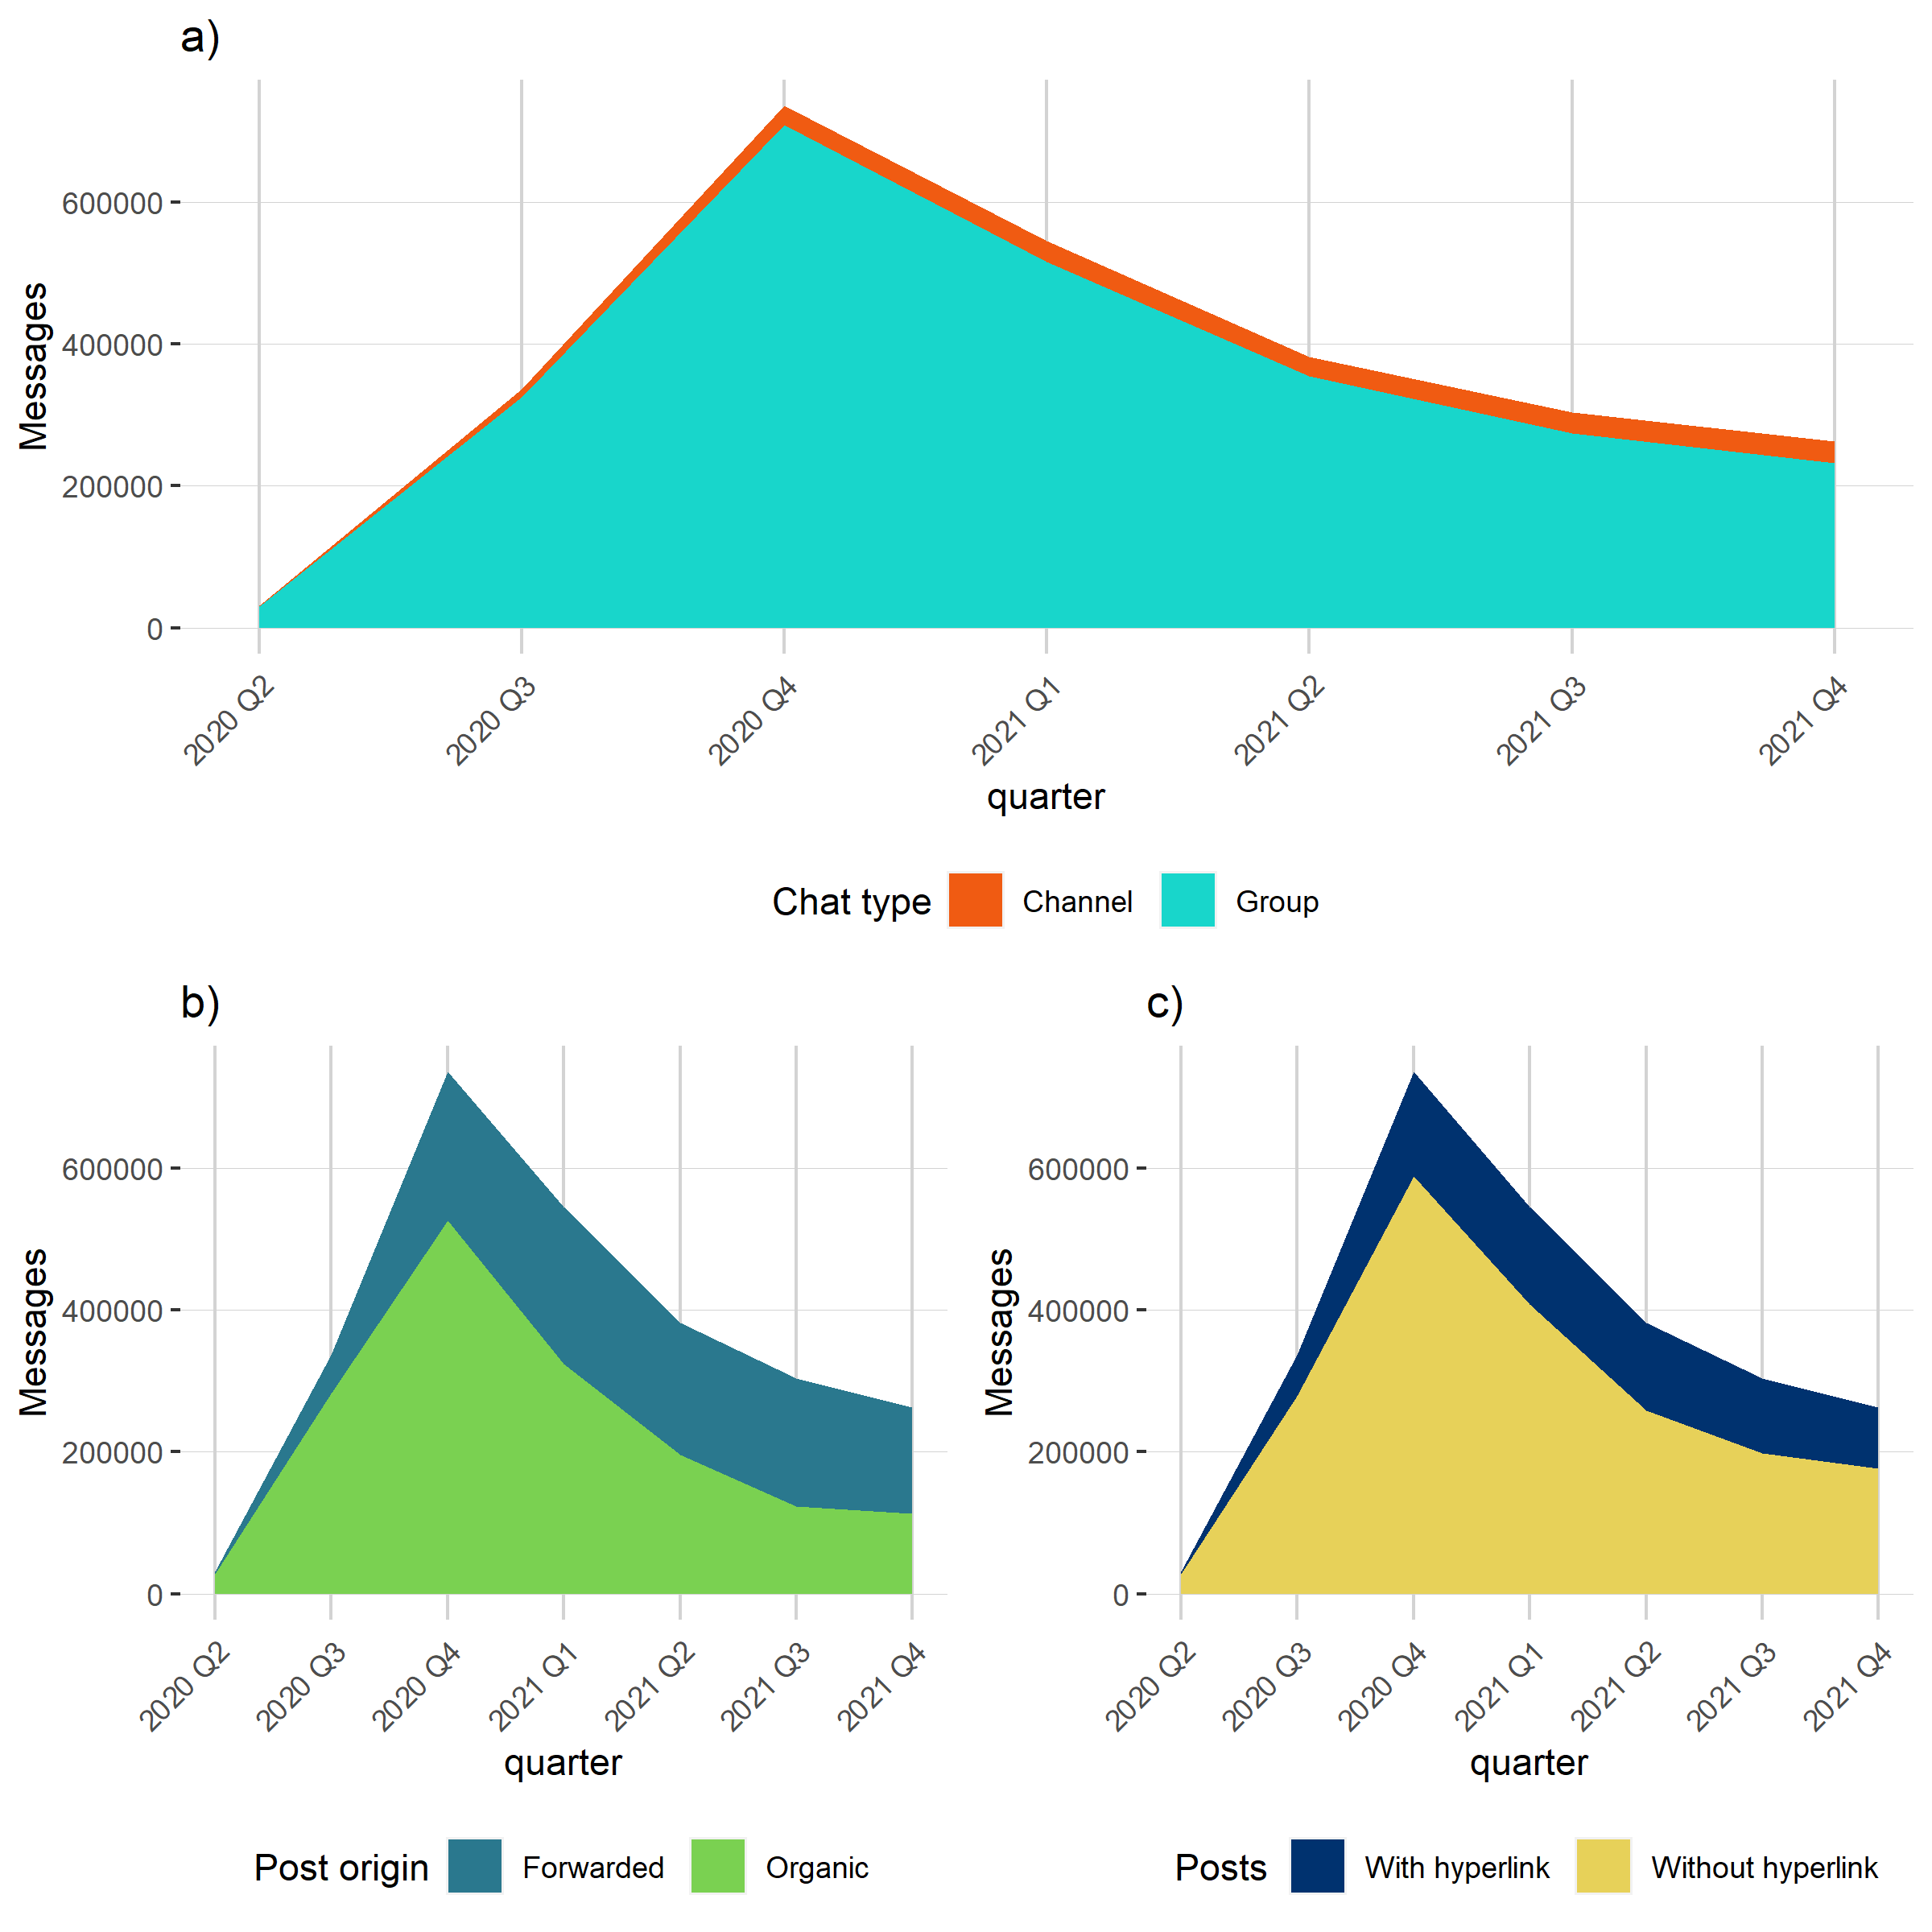
Message characteristics by a) chat type, they have been posted in, b) post origin and c) inclusion of hyperlinks.

A.3 Cluster prevalence of all actor types
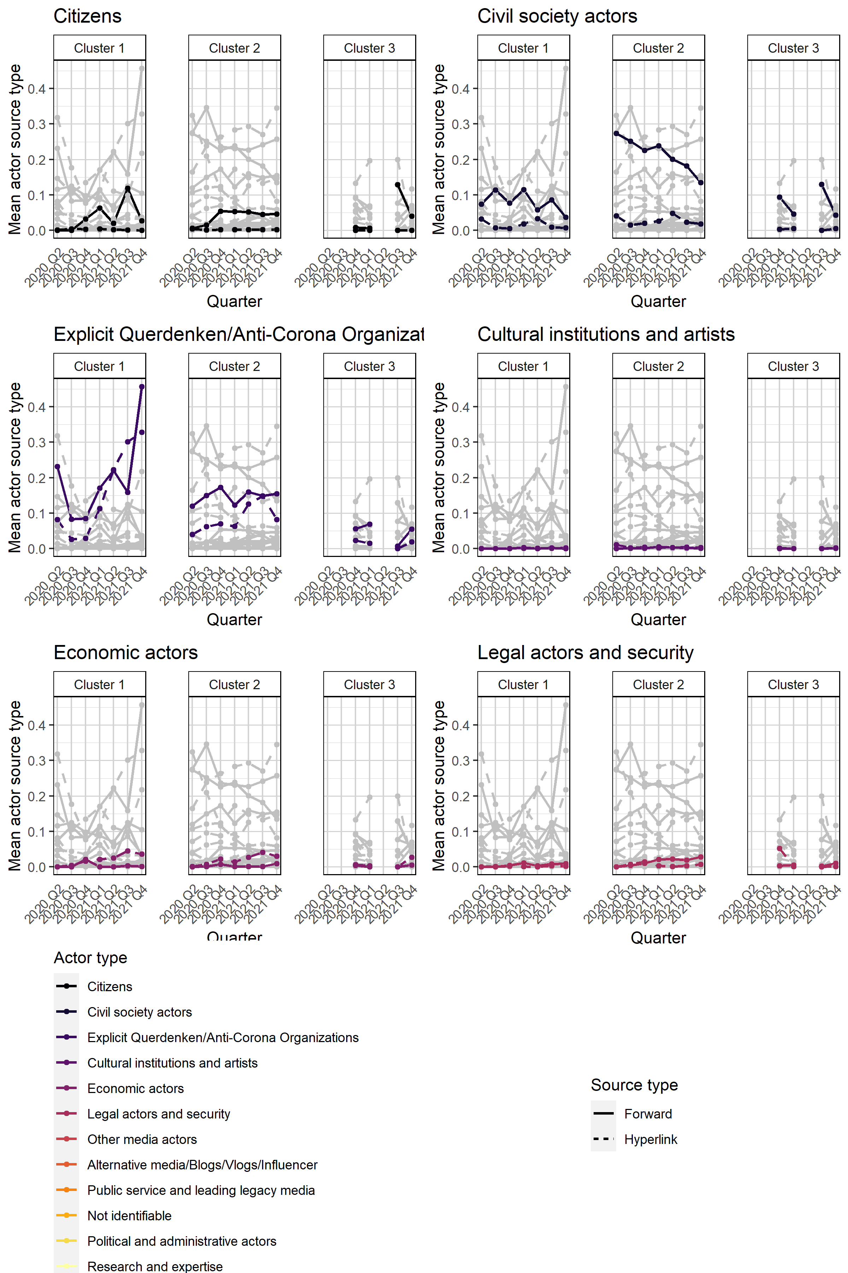
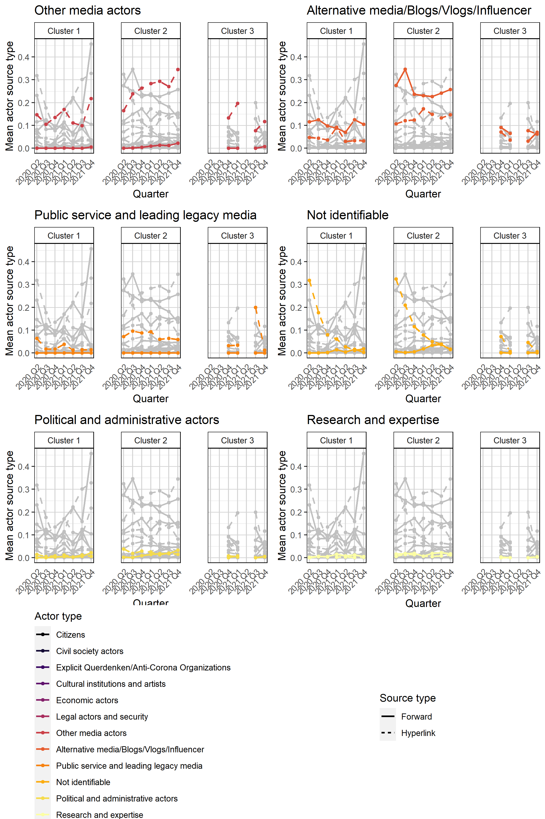

A.4 Reliability coefficients of manual content analysis

Variable | Number of categories | Internal Actors  Telegram Links  n=50 Units of analysis |  | External Actors  External Links  N=51 Units of Analysis
Variable |  | Holsti | Krippendorff’s Alpha | Holsti | Krippendorff’s Alpha
Act1a  Actor type, First level | 10 | 0,91 | 0,75 | 0,94 | 0,80
Act1b  Actor type, Second level | 41 | 0,88 | 0,67 | 0,79 | 0,69
Act3a  Ideology aggregated | 4 | 0,78 | 0,48 | 0,84 | 0,55
Act3b  Ideology aggregated | 3 | 0,87 | 0,60 | 0,89 | 0,56

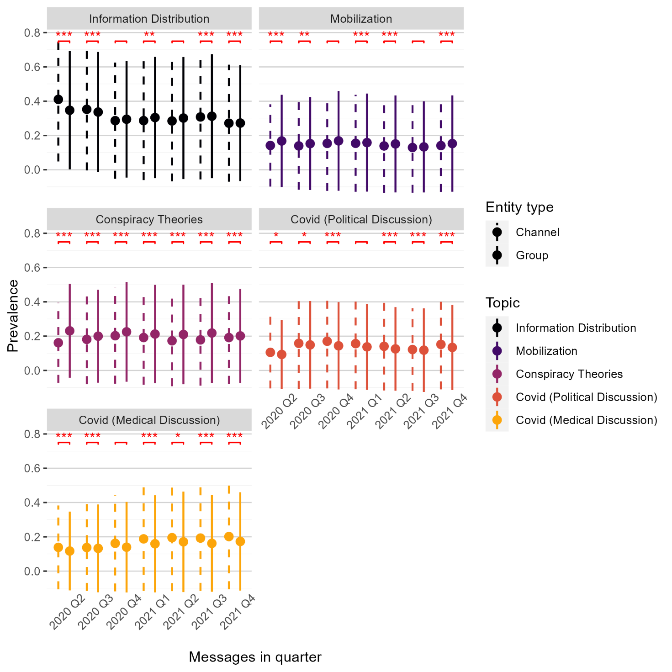
A.5 Two-sample t-tests of topic distributions by entity type
Results of two-sample t-tests of differences between topic prevalence distribution across time and entity types. Dots show the topic prevalence means, error bars show standard deviations. Asterisks denote statistical significance at the ***p < 0.001, **p < 0.01 and *p < 0.05 levels.

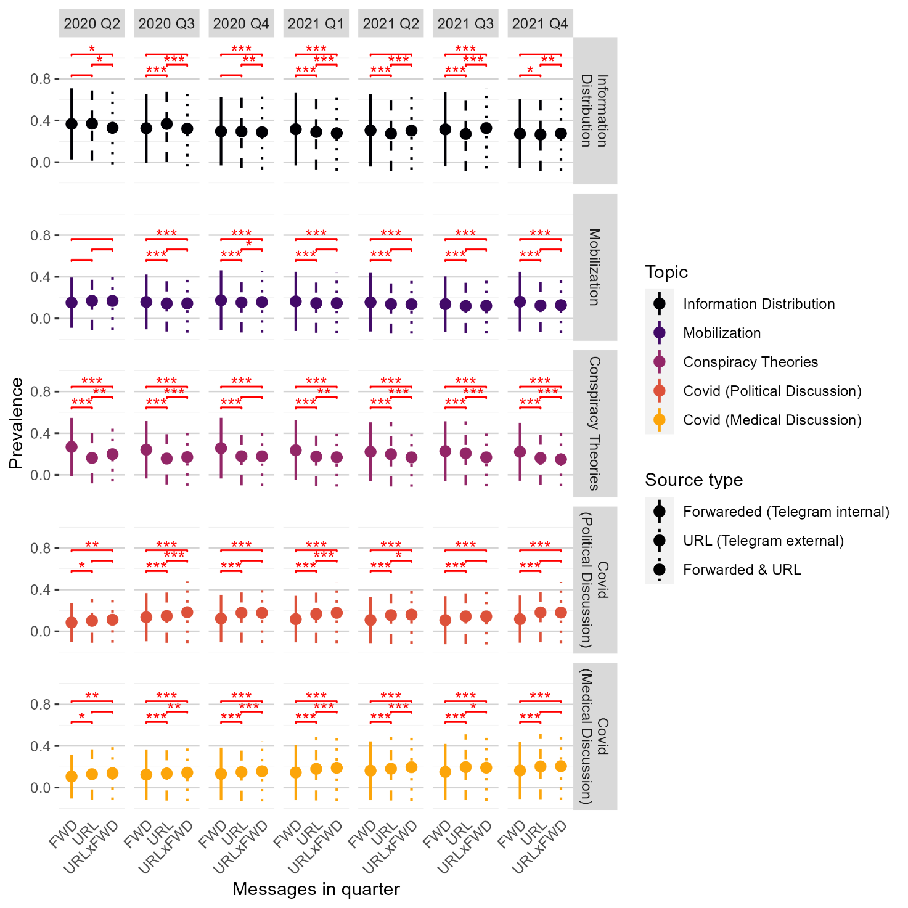
A.6 Pairwise two-sample t-tests of topic distributions by source type
Results of pairwise two-sample t-tests of differences between topic prevalence distributions across time and source types. Dots show the topic prevalence means, error bars show standard deviations. Asterisks denote statistical significance at the ***p < 0.001, **p < 0.01 and *p < 0.05 levels. P-values are adjusted for multiple comparison using the Holm-Bonferroni method (Holm, 1979).

B.1 Codebook

This codebook is used to code actors (and their attributes) involved in the digital communication around the Querdenken movement on Telegram and beyond. The connection to an actor is either established through a Telegram internal hyperlink to a Telegram channel or group or via an external hyperlink to an actor/account outside of the platform (be it online websites, social media accounts on Twitter, Facebook, etc. or else).

Formal variables

ID Identification Number Coding Entity
(Variable ID is given in database. The coders do not enter anything here.)

HANDLE Account Name
(Variable HANDLE is given in database. The coders do not enter anything here.)

LITYPE Link Type
The study includes Telegram-internal channels and groups as well as external hyperlinks. The variable specifies the account-type coded. The differentiation between channels and groups (internal links) and external hyperlinks is given in the database. Coders do not enter anything here.
1 = Telegram internal: Channel
2 = Telegram internal: Group
3 = External Hyperlink (outside of Telegram)

CODER Name of Coder
This variable denotes the Coder of the cases.

1 = anonymized
2 = anonymized
3 = anonymized
4 = anonymized

General coding rules:
There are some general rules the coders should have in mind to avoid mistakes (Sowka et al., 2011; Waldherr et al., 2015):
- Ambiguities in coding are not a sign of incompetency but a natural part of the coding process. Ambiguities should not be solved by coding “something or the other” but should be talked through.
- Ambiguities concerning the allocation of codes should be noted and discussed with the project supervisors. If the ambiguities are of relevance for other codings, they should be documented and discussed within the team of coders.
- The coding should be oriented towards the manifest content of the material. Interpretations that go beyond the coding instructions in this codebook are to be avoided.
- As a general rule, specific codings take priority over general codings. This means that coders should preferably choose specific subcategories rather than more broad meta-categories.

Coding procedure:
- Coding always starts with the information given in the spreadsheet. The central variable for Telegram-internal actors is the self-description provided in the CHANNEL_ABOUT information (checked via the tgstat.com-page, see below).
- If this self-description contains other hyperlinks that specify the channel or group admins, paste those hyperlinks (respectively the channel names, account names ect.) in a browser (including platform domains) and check for self-describing information. Sometimes this information is not given in the CHANNEL_ABOUT column but in the MESSAGE_CONTENT column (e.g., official internet page/account; or if the Telegram message just links to the actors’ account on the platform or to another account of the same actor on other platforms). This information is considered as well.
- When coding external hyperlinks, the coder directly opens the link provided in the spreadsheet and searches for self-descriptions etc. of the actor on the corresponding page.

The coder uses the following parts of the telegram external, linked-to pages/accounts:
- on websites, parts such as “contact”, “about us”, “editorial office”, “team”, “terms of use” and similar; the home page (main page) is considered with respect to the five recent posts, we do not follow additional links
we take the last, most recent texts/posts (not “top posts” or similarly featured posts, which might be displayed at the beginning of a page/result from user rankings).
- on Telegram, Twitter, Facebook, and similar platforms, parts such as the self-description of a user, the language profile etc. plus the first content (up to the first five posts)
  - for Telegram, we use the page https://tgstat.com/channel/@.... and add the name of the channel handle (copy-paste) (note: account names can be different; the handle needs to be the correct one; with respect to the five posts, these are taken from our spreadsheet, not from the stats site; we also check on the stats site who has been forwarded)
  - for Twitter, we use the official Twitter page https://twitter.com/....
  - for FB, coder needs to be logged in with an account at https://www.facebook.com and adds the handle name
  - for Youtube, access is possible without account at https://www.youtube.com/channel/.....
- in the case of YouTube-videos, we click on the name of the poster of a video and if there is a channel of that actor, we check the “about”-page (Kanalinfo) and the first content (up to the first 5 video titles).

We always take visual information in self-descriptions (such as flags, logos, etc.) into account.
If the account language is in a language not understood by the coder, we use Deepl (www.deepl.com/translator) for translation. If the external hyperlink is no longer accessible, we check via the waybackmachine: https://archive.org

- If no self-description and/or no additional links are available: google the actor’s name/institution and use the information you can find as a basis for coding. This procedure is only used for coding if the actor can be unmistakably identified. Otherwise code 999.

Actor characteristics

Act1a, Act1b Actor Type
Choose the social group to which the actor belongs. If an actor can be associated with several categories because he has several positions, and more than one position is mentioned, choose the first mentioned position.

Coding is done in two variables:
First – Act1a – the coder chooses the overarching category an actor belongs to: 10, 20, 30 etc.
Second – Act1b – the coder chooses the specific sub-category within a specific field of actors.

Actor type always refers both to organizations as well as to individuals. The ‘groups’ should be read as including formally or unorganized collectives as well as individuals speaking or acting for such groups. Hints for associations to groups, collectives, organizations can be official logos or references to unions, groups, movements, etc. in the account’s self-description, or a link to the site of such a group, movement, association, such as “Überzeugter Identitärer”, “Unterstützt unsere Gruppe XYZ”, etc. Coder takes visual material such as logos, etc. in the self-description into account.

Individuals that have a blog, vlog, homepage, social media account about a specific topic and produce their own content for those sites are coded according to their specific topic. That is, bloggers, influencers etc. are subsumed under their respective category, i.e. the CEO of Novartis’s blog is the blog of an economic actor, if a scientist is regularly writing about Corona on a blog he is a scientific actor (no matter how prominent he is), a journalist’s blog that of a media actor, a blog of an anti-immigration-actor that of an extreme right civil society actor (no matter how prominent he is), etc.

Key to their classification is the way they present themselves. If they appear in their institutional role (e.g. “This is the blog of journalist XYZ”), record them in the appropriate media category. Bloggers that are not explicitly journalists and/or blog only about a specific topic such as religion, immigration, climate etc. are coded according to their topical focus and role (e.g., in the civil society part or in the science part).

10 Political and administrative actors
This category includes all individual and collective actors with political functions. It is not sufficient to be a member of a party; actors need to have a function within the party/government/political institution in order to be coded as political actors.
Including: individual politicians as well as parties and political fractions, political actors from all levels, government and opposition, (youth) organizations of parties, etc.

11 governments/executive
on all levels (regional, national, supranational such as EU/UN) individuals (ministers, spokespersons, government representatives, etc.) as well as organizations (ministerial bodies) – all executive actors
12 political parties and parliamentary sphere/legislative
Includes official party accounts and actors (party chairman and party sub-organizations) but also individual members of parliament and parliamentary fractions – all legislative actors, e.g. AfDFraktionAGH, AfDimBundestag, Der Dritte Weg, www.bundestag.de
13 public administration/state executive agencies
Robert Koch-Institut, Bundeszentrale für gesundheitliche Aufklärung, Bundesinstitut für Risikobewertung
14 direct-democratic/popular initiative (referendum committee)
Only in the specific case of a referendum/Volksbegehren. Other citizens’ initiatives and action groups are coded as civil society.
15 Other

20 Legal actors and security
21 Courts
(national and international), individual judges
22 Police, Military, Intelligence services
including federal and border police, CIA, BND, Verfassungsschutz, etc.
23 Other
e.g. lawyers

30 Economic actors
31 Business enterprises/firms/companies
If the economic aspect seems to be in the foreground, code here. E.g. app developers: 13three7.com; survey.typeform.com; srkaden.de; amazon.de
If the political aspect is more obvious (impact public debates/opinion), code in civil society.
32 Banking and finance (stock exchange)
paypal.me
33 Unions/employee organizations, employees
34 Employer organizations/ trade and professional associations
35 Other

40 Civil society actors
Civil society refers to individual as well as collective activists, organizations and movements without party affiliation and profit-orientations who want to impact public debates and public opinion (societal power). Foundations are generally coded as civil society actors, regardless of the founding institution; e.g. also foundations of political parties or economic businesses are coded as civil society actors. Individual actors who refer to themselves as “activists” in combination with a movement, NGO etc., or are in some way affiliated with a known non-profit actor, are also coded as civil society, not as a private person. Individuals “fighting” for something want to impact public debate/have a political agenda and are coded here according to their subject.

401 Environmental and climate movements/organizations
Including animal protection. Examples: Greenpeace, BUND (Germany), PETA - People for the Ethical Treatment of Animals, WWF, The Humane Society of the US, Alliance to Save our Antibiotics, Compassion in World Farming (CIWF), Friends of the Earth – foe, environmentalists, WRAP, umweltinstitut.org, Natural Resources Defense Council (NRDC)
402 Migrant organizations
Examples: Jugendliche ohne Grenzen e.V. (JOG), Flüchtlingsrat, DIDF, Türkischer Bund, sea-watch e.V., Migrants Rights Network, Pro Asyl
403 Racist, extreme right, and terrorist organizations
Examples: Identitäre Bewegung, Generation Identity UK & Ireland, Generation Identitær, Generazione Identitaria, Pegida, Blood and Honour, Combat 18, Burschenschaften. Also: individual representatives such as Lutz Bachmann, M. Sellner etc.
404 Women’s rights, LGBTQ, feminist organizations
Examples: femen, terre des femmes, Deutscher Frauenrat, Jugendnetzwerk lambda, Lesben- und Schwulenverband Deutschland (LSVD)
405 Solidarity, human rights, peace movements and organizations
This includes only private organizations such as Anti-Racist Alliance, Amnesty International, Terre des Hommes, médecins sans frontières, Alliance Sud, Erklärung von Bern, Germanwatch, Gesellschaft für bedrohte Völker, Oxfam, Welthungerhilfe, Brot für die Welt, Population Connection, Südwind Institut, Farmer-to-Consumer Legal Defense Fund (FTCLDF) etc.

406 Welfare organizations
Examples: Red Cross, Arbeiterwohlfahrt. Der Paritätische, Caritas
Note: does not include state welfare agencies (these are coded as state executive agencies).

407 Churches and religious organizations
Examples: Evangelische Kirche in Deutschland, Papst Franziskus, but also „Juden in der AfD“
408 Consumer organizations
Examples: Verbraucherzentrale, Die Verbraucher Initiative, Stiftung Warentest, Bund der Energieverbraucher, Verbraucher fürs Klima, Consumers Union, consumer advocates, consumer activists.

409 Explicit Querdenken-/Anti-Corona-Organizations
Includes explicit Anti-Corona-Measures-Actors even if not extreme actors/positions Examples: app.querdenken-711.de
410 Other
Civil society actors that don’t fall into any of the categories above regardless of their partisanship. This also includes distinctive conspiracy theory actors.
Examples: QAnon

50 Media and journalists
We can identify an official account: journalists, media, news agencies, other media actors such as bloggers, filmmakers, Youtubers, publishing companies.
If individual persons blog in an expert role (e.g. about science) they are coded as scientific expert (no matter how prominent they are). If individual persons blog about a specific topic, they are coded according to the specific topic (no matter how prominent they are, see above). Media accounts with a focus on science are coded as media. Including: accounts of individual journalists (if this is obvious from the information given in the profile), official accounts of legacy and online media, influencers, and bloggers, podcasters etc.

51 Public service media and leading legacy media
(national and transnational, online and offline, but not regional public media that are coded in 53)
Examples: Spiegel Online, WELT, Le Monde, Bild
Use provided list plus x
52 Alternative news media (online and offline)
Use provided list plus x
Based on self-description on front-page/about section as: alternative/different/anti-mainstream/revolutionary, and/or keywords and phrases such as politically incorrect/controversial/provocative/focusing on issues disregarded by other media/free of censorship/dedicated to the freedom of the press/committed to the truth etc.
Media accounts need to have some sort of self-description as media/information offer, have an impressum/editorial responsibility, and periodicity. Usually not one-person enterprises (see blogs).
53 Other news media (online and offline) and special interest media
such as regional and local media, online native media (such as technical, lifestyle magazines etc.)
54 Blog, Vlog, Podcast, Social media influencer
Included here are private persons that link to their own blogs/homepages or explicitly state that they are bloggers in their self-description; NOT: blogs by media outlets, Columnists are coded under the respective media outlet, all journalists are coded according to their organizational affiliation, if there is no affiliation and they are freelance journalists and media pundits, code here. Also, journalists that entertain private social media accounts.
Bloggers/influencers as media actors versus civil society actors: Bloggers/influencers as media actors explicitly self-label as bloggers/journalists/information providers, have some sort of impressum/responsibility statement, are usually not anonymous persons/accounts and regularly post on a variety of topics.
Example: HeimatgewaltfreiVereint/Team Heimat; UnabhaengigerInfokanal

Bloggers/influencers as civil society actors: If their blog etc. only deals with a specific topic such as climate change, migration or religion, they are coded in terms of their topic and not simply as a blogger. (Consider political agenda/activism vs. information provider.)

55 Publishing houses, Wire services, news agencies

56 News aggregator sites and channels, Redistributers, Search Engines
Google.com
57 Digital (information/data) services
internet archives, cloud services, external data storage: Wikipedia; docs.google.com;
58 Social media platforms
Home pages of social media, such as the Telegram home page (NOT an individual account); nitter.nixnet.services; Gab etc.
59 Other

60 Research and expertise
Note: Not everybody who has a university degree is a scientific actor. There needs to be an official position in a research organization or at a University etc.
61 Academia
(public and private) universities and public research institutions and experts
62 Other Research Organization
think tanks and research-oriented funds; includes partisan think tanks and funds, such as Konrad-Adenauer-Stiftung, Initiative Neue Marktwirtschaft
63 Private Research Organization
Market and opinion research and polling including commercial services providing data
64 Health experts (not being scientists, e.g. doctors, nurses, etc.,)
65 Other
Note: We code explicit scientific publishers, linked to research, here, e.g. mdpi.com .

70 Cultural Institutions and artists
Including: popular actors from sports, musicians, authors, artists, etc. (i.e. so-called stars). Includes social media stars and influencers focused on cultural topics.
In order to be coded as cultural actor instead of citizen, the person needs a certain degree of popularity. Indicators include: Presence in legacy media (TV, magazines, etc.), more than 1000 followers on social media, has released a CD, played in a movie, etc. Examples: Bands, Models, soccer players as well as their clubs, movie actors.
70 is coded in both Act1a and Act1b, no further differentiation.

80 Citizens (e.g. single private person)
Only private actors and accounts of individuals that do not belong to any code above.
If we cannot find any information on the profile, we also assume that the account belongs to a single private person.
Private persons that have a political agenda regarding specific topics but are not activists (social power) and also do not produce their own content also fall under this category.
An indicator for citizens is also limited reach/popularity (below 1000 followers).
80 is coded in both Act1a and Act1b, no further differentiation.

90 Other Actor
90 is coded in both Act1a and Act1b, no further differentiation.

999 Actor not identifiable
This category is coded if the actor cannot be decided based on the information provided or information is technically not available [e.g. Telegram account or other links are no longer active/available/no access]
Please make a comment in the comment column!

Act2 Actor scope
The notion of scope refers to the organizational extension of the organization. If it is not identifiable through the name or self-description, choose “999”. The country of an actor is where the actor is permanently resident, i.e., not necessarily corresponding to the actor's nationality. Use country-specific domain endings as indicators, where available (.de, dk, ...). For websites with non-country-specific domains (.net, .org, ...), check the imprint. For multinational actors (such as amazon.de/amazon.com/…,) disregard domain ending.

10 Supranational and Multinational
multinational, supranational, or global institutions, organizations, such as UN, WTO, Amnesty International, EU (EU Commission, European Court of Justice) G20, ASEAN, etc. as well as companies of a multinational or global character)
20 National actor other country than Germany (including regional and local)
Follow Up: String variable Act2a below
30 National: Germany
e.g., national political parties like Dritter Weg. Note: Citizens are always coded as national scope, even if their profile description provides other information (e.g. “The world is my home.”).
40 Regional: Germany
e.g., regional branches of national organizations like Identitäre Hessen or regional media, including specifications such as Nordhessen etc. Any reference to a region accounts for this code.
50 Local: Germany
e.g., local branches of organizations or local media, any reference to a specific town (Stuttgart) or Landkreis accounts for this code. Specific postal codes account for a local scope.
999 Scope not identifiable
Please make a comment in the comment section to discuss with project supervisors

Act2a String Variable: Coding of Other Country
If you coded 20 in Act2, please record the country (in English) here by simply writing the Name of the country down.

Act3 Actor partisanship (ideological orientation)
This categorization is adapted from the codebook by Benert (2020) and rests on the MARPOR-project (Volkens, Lehmann, et al., 2019). The MARPOR-project classifies parties into party families based on expert evaluations of parties’ profiles. In combination with parties’ positions on four areas of policies (state policy, economic policy, social policy, and foreign policy) coded in the manifesto data set, it can be predicted which policy positions are taken up by members of which party families (see Klingemann & Budge, 2013).
We expand this classification to other actor groups than political parties/actors by transferring positions visible in self-descriptions etc. and messages/issues addressed to the categorization of the MARPOR-project.
For parties and all political actors belonging to a party, the categorization is coded as described in the examples listed below (taken from and therefore equal to the MARPOR-data set (Volkens, Krause, et al., 2019).
For actors belonging to other actor groups, the categorization must be decided based on information from their Telegram profiles and/or websites, other social media accounts as specified above (see coding procedure on what to include).
This is done as follows: (1) For all actors who disclose affiliation to a party on their Telegram/other social media profile (e.g. “proud AfD-supporter”), the classification of the party is used as political leaning of the actor. (2) If actors provide a self-description that fits the categorization (e.g. “social democrat from head to toe”), the self-description is used. (3) Otherwise any information about issues/policies of importance to the actor (e.g. “climate change activist”) can be used to evaluate political leaning according to the descriptions of the categories below. The policy positions are numbered according to their importance for the respective actor family (see also Appendix B.2, Table 1).

For media, a known editorial stance (political parallelism) can also serve as an indication (see provided lists). Public service media are coded as 9.
Think-tanks, funds, interest and other societal organizations are coded as their affiliated party, where applicable, else if characterized by partisan keywords.
Non-partisan institutions which should by definition be non-partisan (such as courts) are coded as 9.
In case of insufficient or ambiguous information, the codes 99 (other) or 999 (cannot be evaluated) can be used.
We take flags, logos, and other visual material in the self-descriptions/account descriptions on social media into account for coding ideological orientation.

1 Socialist or other left actors
(1) The most central issue of socialist and left actors are peace and détente. Issues and positions addressed include peace as a general goal; belief in peace and peaceful means of solving crises; desirability of joining in negotiations with hostile countries; favorable mentions of decreasing military expenditures; disarmament; the ‘evils of war’; promises to reduce conscription.
(2) Furthermore, they often promote the expansion of the welfare state, including the following positions: need to introduce, maintain or expand any social service or security scheme; support for social services such as health service or social housing; need to expand and/or provide educational provisions at all levels; favorable references to labour groups, working class, unemployed; support for trade unions; good treatment of manual and other employments; concept of equality; need for fair treatment of all people; special protection for underprivileged; need for fair distribution of resources; removal of class barriers; end of discrimination such as racial, sexual etc.
(3) To a lesser degree they might also refer to positions on planned economy. These include partial or complete government ownership (e.g. of land), direct government control of economy; control over prices, wages, rents, etc.; publicly owned industries, positive use of Marxist-leninist concepts; negative references to privatization; domestic economic protectionism (e.g. quota restrictions). Examples: Die Linke, linksjugend [‘solid]
2 Ecologist actors
(1) The most central issue of ecologist actors is environmental protection. This includes references to the preservation of the countryside, forests, etc.; the general preservation of natural resources against selfish interests; environmental improvement; favorable mentions of anti-growth politics and steady-state economy; ecological orientation as a way of life (e.g. vegan lifestyle for reasons of animal and environmental protection).
(2) To a lesser degree, they might also refer to positions in the field of peace and détente, including peace as a general goal; belief in peace and peaceful means of solving crises; desirability of joining in negotiations with hostile countries; favorable mentions of decreasing military expenditures; disarmament; the ‘evils of war’; promises to reduce conscription.
Examples: Bündnis 90/Grüne, Fridays for Future, Scientists for Future, climate change activists and organizations, animal rights activists and organizations
3 Social democratic actors
(1) The most central issue of social democratic actors is the expansion of the welfare state. Issues and positions addressed include the need to introduce, maintain or expand any social service or security scheme; support for social services such as health service or social housing; need to expand and/or provide educational provisions at all levels; favorable references to labour groups, working class, unemployed; support for trade unions; good treatment of manual and other employments; concept of equality; need for fair treatment of all people; special protection for underprivileged; need for fair distribution of resources; removal of class barriers; end of discrimination such as racial, sexual etc.
(2) To a lesser degree they might also refer to economic infrastructures, including the importance of modernization of industries, transport, and communication; importance of science and technological development in industry and research; the paradigm of growth.
Examples: SPD, Jusos, SPE, Young European Socialists (YES), Labour Party, SPÖ, PSOE
4 Liberal actors
(1) The most central issues of liberal actors are market economy and the limitation of the welfare state. Positions and issues addressed include favorable mentions of free enterprise and capitalism; superiority of individual enterprise over state and control systems; private property rights; need for unhampered individual enterprise; positive references to privatization; negative references to governmental control of economy; support for traditional economic institutions such as the stock market and baking system; support for strong currency; need for wage and tax policies to induce enterprise; encouragement to start enterprises; regulation to make private enterprises work better; actions against monopolies and trusts; defense of consumer and small businesses; encouraging economic competition.
(2) Positions on the limitation of the welfare state include limiting expenditures on social services or social security; private welfare provisions because of economic constraints; desirability of competition in welfare service provisions; limiting expenditures on education; private education; desirability of competition in education; abuse of power trade unions.
(3) To a lesser degree they might also refer to human rights and freedom, including the importance of personal freedoms and human rights, such as freedom from coercion in the political and economic sphere; freedom of speech, freedom from bureaucratic control; individualism. Freedom of nations to decide freely.
Examples: FDP, Neos, Liberal Democrats
5 Christian democratic actors
(1) The most central issue for Christian democratic actors is traditional morality (law and order). Positions include favorable mentions of traditional moral values; the prohibition, censorship, and suppression of immorality and unseemly behavior; maintenance and stability of family and religion; enforcement or encouragement of cultural integration; better law enforcement; actions against crime; support of and more resources for the police, tougher court action; general sense of crises and alienation; negative mentions of cultural autonomy of Roma. Generally, Christian democratic actors can be conceived as a special case between classic program party families and sociocultural party families. Therefore, they are expected to address special interest issues as well as more general issues of public concern (see also Table 1 in the appendix B.2).
Examples: CDU/CSU
6 Conservative actors
(1) The most central issues of conservative actors are market economy and military strength. This includes favorable mentions of free enterprise and capitalism; superiority of individual enterprise over state and control systems; private property rights; need for unhampered individual enterprise; positive references to privatization; negative references to governmental control of economy; support for traditional economic institutions such as the stock market and baking system; support for strong currency; need for wage and tax policies to induce enterprise; encouragement to start enterprises; regulation to make private enterprises work better; actions against monopolies and trusts; defense of consumer and small businesses; encouraging economic competition.
(2) Military strength includes the following positions: the need to maintain or increase military expenditure; modernizing armed forces; improvement in military strength; rearmament and self-defense; need to keep military treaty obligations; need to secure adequate manpower in the military.
(3) To a lesser degree they might also address the issue of economic infrastructure. This includes: the importance of modernization of industries, transport, and communication; importance of science and technological development in industry and research; the paradigm of growth.
Examples: Open Europe, ECR (German: Europäische Konservative und Reformer (EKR))
7 Nationalist actors
(1) The most central issues of national actors are nationalism and military strength. This includes the following positions: appeal for national efforts and solidarity; need for society to see itself as united; appeal for public spiritedness; decrying anti-social attitudes in times of crises; support for public interest; national independence and sovereignty, opposing internationalism; need to maintain national security in all spheres of societal life (e.g. politics, economy, science, etc.); hostile mentions of EU; opposition to specific European policies which are preferred by European authorities; appeal to patriotism and/or nationalism; suspension of some freedoms in order to protect the state from subversion; support for established national ideas.
(2) Military strength positions relate to the need to maintain or increase military expenditure; modernizing armed forces; improvement in military strength; rearmament and self-defense; need to keep military treaty obligations; need to secure adequate manpower in the military.
(3) To a lesser degree they might also refer to positions related to centralization, including opposing political decision-making at lower levels; support for more centralization in political and administrative procedures.
Note: This category also includes all radical right and right-wing populist actors and their positions: Ethno-nationalism, xenophobia, anti-elitism, anti-establishment, anti-LGBTQ+ etc.
Examples: AfD, Identitäre Bewegung, NPD, Marine Le Pen, Tichys Einblick, Reichsbürger
8 Special issue actors
Special issue actors are defined by very specific interests that relate to small parts of society only and are not covered by any other code. For political parties, this usually refers to parties with only one electoral goal (e.g. Brexit party). The issues addressed by different special issue actors can be very diverse, including but not limited to Brexit and abortion laws.
This category also includes special interest media.
This category also includes alliances of actors with usually diverse positions and/or interests who formed a strategic coalition for a certain situation/goal (e.g. in electoral contexts). This category is used for alliances of actors who would fall into different categorizations if coded separately.
Examples: Volt, Metal Hammer, Corona as special issue
9 No political agenda
This categorization includes all actors whose positions and functions are explicitly not affected by any political agenda. This includes state actors (e.g. Police, Military) who act on behalf of the state but should not have political agendas on their own. This category is also used for media actors who explicitly point towards their neutrality in reporting as well as scientific institutions (which are generally meant to be neutral research institutions).
Note: This must not necessarily refer to private accounts of researchers/media actors ect. – if they denote political leanings in their profile descriptions, they are coded accordingly.
This code does NOT include actors whose information is insufficient to decide on a political affiliation, these actors are coded as 999.
Examples: Leopoldina, RKI, universities
99 Other/Unclear
This category is used for actors who do disclose political statements in their Telegram or social media profiles or on their websites, but for which the information given is ambiguous.
999 Cannot be evaluated (no information)
This category is coded whenever the political leaning of an actor cannot be coded because no information is given in the actor’s profile/content or when the account is no longer available.

Act4a, Act4b Actor topical focus
For each actor, we code for an actors’ main topical focus. This topical focus can relate to partisan themes specific to ideological groups but also to general themes of societal concern (see Zick & Küpper, 2021, p. 69) which apply across ideological divisions.

Note: This variable is NOT meant to code what an actor is talking about overall, but what constitutes its main self-describing topic. That means, the self-description of an actor should always be taken into account first – considering any parts/accounts as detailed in the coding procedure. We also consider self-describing parts on websites, especially “about” and “support us” sections, including information given in the site structure itself, e.g. details in headers, footers and sidebars. In addition and rather to substantiate in case not much information is available, we use the first up to 5 messages as given in the spreadsheet (Telegram)/ given on an accounts main page. If the information in the self-describing parts is sufficient for coding actors’ topical focus, do not go on further.

If this information includes different thematic (partisan) aspects, we code the main topical aspect and a second-important topical aspect. The main aspect is the one most prominently addressed/most visible, that should come through in at least three but better in all messages. If in doubt, code the first mentioned aspect. We only code a second-important topical aspect if there is a substantial second topical aspect, otherwise code None = 90 in Act4b. Substantially means the second topic is not only an effect/outcome/rationale of the first topic but introduces another issue or claim that constitutes an actors’ main goal/self-understanding.

If no topical focus (partisan theme/theme of societal concern) is discernable, code None = 90 in Act4a and/or Act4b. For example, mainstream media usually do not have one main driving issue that stands/self-describes the actor itself. “20” is not coded for whole topical areas, such as politics, finance, etc.

1 Climate Change
2 Corona Pandemic and Measures, (Anti-)Vaccine
3 Migration, (Anti-)Multiculturalism, (Anti-)Xenophobia
4 Islamism, (Anti-)Islam
5 (Anti-)Israel, (Anti-)Semitism
6 (Anti-)Feminism, (Anti-)LGBTQ+
7 Nationalism and Patriotism
In the sense that this is an important self-describing part of an actor. References to (ethno-cultural) identity, homeland, etc.
8 Right-wing (Extremism)
In the sense of right-wing (extremism) as an object, what is talked about, what is the subject an actor deals with, not in the sense of an actor’s ideology.
9 Left-wing (Extremism)
In the sense of left-wing (extremism) as an object, what is talked about, what is the subject an actor deals with, not in the sense of an actor’s ideology. e.g. anti-left as aim of a group
10 Social divides/cleavages/inequality
11 Restriction of fundamental rights, Freedom of Speech,
“Aufklärung“, Human rights, etc.
12 Anti-elite/Anti-public Sector/Anti-establishment (including media criticism)
Including generalized calls for change
13 Anthroposophy/Esoteric Topics/Thinking
e.g. our natural self-healing powers are strong enough, alternative medicine/scholastic medicine
14 Conspiracy Topics/Thinking
e.g. secret organizations, secret powers that rule the world, vaccines and microchips, QAnon
15 (Loss of) Traditions and Values
16 Isolation/Loneliness within society
17 Competition/Self-performing pressure within society
20 Other = please write the topic into the “comment” column
90 None

999 Cannot be evaluated
Link not accessible

Codebook is based on
Benert, V. (2020). Codebook Project: The Europeanisation of Networked Public Spheres. Berlin: Weizenbaum-Institut/Freie Universität Berlin.
Heft, A. (2019). Codebook Project “Measuring movement-party networks on the political right: A study of national and transnational linkages across six countries”. Berlin: Weizenbaum-Institut/Freie Universität Berlin.
Waldherr, A., Miltner, P., Pfetsch, B., Schmid-Petri, H., Häussler, T., Adam, S., Streibl, W., & Bennett., W. L. (2013). Codebook for the analysis of frames in online documents and newspaper articles. COAB-Project: The impact of challengers’ online communication on media agenda building – a comparison across countries and issues. https://www.polsoz.fu-berlin.de/kommwiss/arbeitsstellen/kommunikationstheorie/forschung/coab/COAB_Codebook_Food-Safety_2013-12-04.pdf

References
Klingemann, H.-D., & Budge, I. (2013). Using the Manifesto Estimates to Refine Party Family Placements. In A. Volkens, J. Bara, I. Budge, M. D. McDonald, & H.-D. Klingemann (Eds.), Mapping Policy Preferences from Texts III: Statistical Solutions for Manifesto Analysts (pp. 49–65). Oxford University Press.
Klingemann, H.-D., Volkens, A., Bara, J., Budge, I., & McDonald, M. (2006). Mapping Policy Preferences II. Estimates for Parties, Electors, and Governments in Eastern Europe, the European Union and the OECD, 1990-2003. Oxford University Press.
Sowka, A., Klimmt, C., Gollwitzer, M., Sjöström, A., Rothmund, T., & Bushman, B. J. (2011). Representation of social sciences in the media coverage on violent video games. Codebook: Quantitative content analysis of German and US-American print media between 1999 and 2011. Department of Journalism and Communication Research, Hanover University of Music, Drama, and Media.
Volkens, A., Krause, W., Lehmann, P., Matthieß, T., Merz, N., Regel, S., & Weßels, B. (2019). The Manifesto Data Collection. Manifesto Project (MRG/CMP/MARPOR). Version 2019b. https://doi.org/10.25522/manifesto.mpds.2019b
Volkens, A., Lehmann, P., Matthieß, T., Merz, N., Regel, S., & Weßels, B. (2019). The Manifesto Project Dataset - Codebook. Manifesto Project (MRG/CMP/MARPOR). Version 2019a.
Waldherr, A., Miltner, P., Pfetsch, B., Schmid-petri, H., Häussler, T., Adam, S., Streibl, W., & Bennett, W. L. (2015). Codebook for the analysis of frames in online documents, newspaper articles and political documents. https://www.polsoz.fu-berlin.de/kommwiss/arbeitsstellen/kommunikationstheorie/forschung/coab/COAB_Codebook_Food-Safety_2015-07-09.pdf
Zick, A., & Küpper, B. (Eds.). (2021). Die geforderte Mitte. Rechtsextreme und demokratiegefährdende Einstellungen in Deutschland 2020/21. Dietz.

B.2 Codebook appendix

Table 1: Dominant policy characteristics of the party families (discriminant functions distinctly differentiating between election programs of parties)

Party family | Dominant policy  characteristics | Weight for index (rounded correlation  with discriminant function)
Classic program families
Left/socialist | Peace and détente  Welfare state expansion Planned economy | 0.5  0.5  0.3
Social democrat | Welfare state expansion  Economic infrastructure | 0.5  0.3
Liberal | Market economy  Welfare state limitation Freedom and human rights | 0.5  0.5  0.3
Conservative | Market economy  Military strength Economic infrastructure | 0.6  0.5  0.4
Nationalist | National orientation  Military strength Centralization | 0.5  0.5  0.2
In between families
Christian democrat | Traditional morality: law and  order | 0.9
Sociocultural families
Ecologist | Environmental protection  Peace and détente | 0.9  0.3
Agrarians | Agriculture | 0.9
Ethnic minorities | Decentralization  Social groups | 0.8  0.1
Source: adapted from (Klingemann & Budge, 2013, p. 64)

Table 2: MARPOR classification scheme of election programs: definition of categories

Category |  |  |  |  | Definition
State Policy
Freedom and human rights |  |  |  |  | Favourable mentions of importance of personal freedoms and human rights, such as freedom from coercion in the political and economic sphere; freedom of speech, freedom from  bureaucratic control; individualism. Freedom of nations to decide freely.
Democracy |  |  |  |  | Favourable mentions of democracy as a method or goal in national and other organizations; involvement of all citizens in decision-making, as well as generalized support for a country’s democracy. General references to the transition process of one-party states to pluralist  democracy.
Constitution |  |  |  |  | Preferences for specific constitutions; use of constitutionalism as a policy argument. Preferences for a Republic, a Monarchy, or a Presidential regime. Reference to citizenship and  election laws. Support for checks and balances and separation of powers.
Centralization |  |  |  |  | Opposition to political decision-making at lower political levels; support for more centralization in political and administrative procedures.
Decentralization |  |  |  |  | Support for federalism or devolution; more regional autonomy for policy or economy; support for keeping up local and regional customs and symbols; favourable mentions of special  consideration for local areas; deference to local expertise. Support for a strengthening of republican powers. Negative references to exerting strong influence (political, military, and commercial) over other states; negative references to controlling other countries as if they were part of an empire; favourable mentions of decolonization; favourable references to greater self-government and independence of colonies; negative reference to imperial behaviour of countries. Cultural diversity, communalism, cultural plurality, and polarization; preservation of autonomy of religious, linguistic heritages within the country, including special  educational provisions. Favourable mentions of cultural autonomy in general.
Modes of government |  |  |  | Favourable mentions of strong government, including government stability; party’s competence to govern and/or other parties’ lack of such competence. Need for efficiency and economy in government and administration; cutting down civil service; improving governmental procedures; appeal to make the process of government and administration cheaper and more effective. Need to eliminate corruption, and associated abuse in political  and public life.
Communists, positive |  |  |  | Cooperation with former authorities and communists in the period of transition; pro communist involvement in the transition process; ‘let sleeping dogs lie’ in dealing with the nomenklatura. ‘Hunting the witches’: negative references to the situation in public life, after the election of the Supreme Council. References to the need of a broader political coalition, need for cooperation on the political level, and necessity of collaboration of all political forces, including the communists in the current crises situation. Rebuilding the USSR. Negative  references to physical restitution of property to previous owners.
Communists, negative |  |  |  | Against communist involvement in democratic government; weeding out the guilty and the collaborators from government service. References to civic rehabilitation of politically persecuted people in the communist era; references to juridical compensation concerning communist expropriations; moral compensation. Favourable references to physical restitution  of property to previous owners.
Economic policy
Market economy |  |  |  | Favourable mentions of free enterprise, capitalism; superiority of individual enterprise over state and control systems; favourable mentions of private property rights, personal enterprise and initiative; need for unhampered individual enterprises. Favourable references to privatization and of privatization by vouchers. Negative references for general need for direct government control of the economy. Support for the concept of free trade. Need for reduction of budget deficits; retrenchment in crisis, thrift and savings; support for traditional economic institutions such as the stock market and banking system; support for strong currency. Need for wage and tax policies to induce enterprise; encouragement to start enterprises; need for financial and other incentives. Need for regulations to make private enterprises work better; actions against monopolies and trusts; and in defense of consumer and small business;  encouraging economic competition.
Planned or mixed economy |  |  |  | Government ownership, partial or complete, including government ownership of land. General need for direct government control of the economy; control over prices, wages, rents, etc. Favourable references to creation or preservation of cooperative or non-state social ownership within a market economy. Favourable mentions to publicly owned industry. Position references to socialist property and negative references to privatization; positive use of Marxist-Leninist concepts for an analysis of the economic situation. Demand-oriented economic policy, economic policy devoted to the reduction of depressions and/or to increase private demand through increasing public demand and/or through increasing social expenditures. Favourable mentions of extensions or maintenance of tariffs to protect internal markets; other domestic economic protectionism such as quota restrictions. Favourable mentions of the need for the collaboration of employers and trade union organizations in overall economic planning and direction through the medium of tripartite bodies of government, employers, and trade unions. Favourable mentions of long-standing economic planning of a consultative or indicative nature, need for government to create such a plan.  Negative references to privatization.
Economic infrastructure |  |  |  | Importance of modernization of industry and methods of transport and communication; importance of science and technological development in industry; need for training and research. Need to encourage or facilitate greater economic production; need to take measures to aid this; appeal for greater production and importance of productivity to the economy; the  paradigm of growth.
Environmental protection |  |  | Preservation of countryside, forests, etc.; general preservation of natural resources against selfish interests; proper use of national parks, soil banks, etc.; environmental improvement. Favourable mentions of anti-growth politics and steady-state economy; ecological orientation  as a way of life; Green politics.
Agriculture |  |  | Support for agriculture and farmers; any policy aimed specifically at benefiting agriculture and farmers.
Social policy
Traditional morality, law and order |  |  | Favourable mentions of traditional moral values; prohibition, censorship, and suppression of immorality and unseemly behaviuor; maintenance and stability of family and religion. Enforcement or encouragement of cultural integration. Better law enforcement; actions against crime; support of and more resources for the police: tougher court action. General  sense of crisis and alienation. Negative mentions of cultural autonomy of Roma.
Cultural  libertarianism |  |  | Opposition to traditional moral values; support for divorce, abortion, etc. Multiculturalism, pro Roma.
Welfare state, limitation |  |  | Limiting expenditure on social service and social security. Necessity of private welfare provisions because of economic constraints; desirability of competition in welfare service provisions; private funding in addition to public activity. Limiting expenditure on education. Necessity of private education because of economic constraints: desirability of competition in education. Necessity of restrictive provisions because of economic constraints; private funding  in addition to public activity. Abuse of power of trade unions.
Welfare state, expansion |  |  | Favourable mentions of need to introduce, maintain, or expand any social service of social security scheme; support for social services such as health service or social housing. Need to expand and/or improve educational provision at all levels. Need to provide cultural and leisure facilities including arts and sport; need to spend money on museums; art galleries, etc.; need to encourage worthwhile leisure activities and cultural mass media. Favourable references to labour groups, working class, unemployed; support for trade unions; good treatment of manual and other employees. Concept of equality; need for fair treatment of all people; special protection for underprivileged; need for fair distribution of resources; removal of class  barriers; end of discrimination such as racial, sexual, etc.
Social group politics |  |  | Favourable mention to middle class, professional groups, such as physicians or lawyers; old and new middle class. Favourable references to underprivileged minorities who are defined neither in economic nor in demographic terms, for example, the handicapped, homosexuals, immigrants. References to ethnic minorities in foreign countries. References to ethnic minorities living in the country such as Latvians living in Estonia, and so on. Favourable mentions of, or need for, assistance to women, old people, young people, war participants,  refugees, linguistic, and all other special interest groups.
Foreign policy
Military strength |  |  | Need to maintain or increase military expenditure; modernizing armed forces and improvement in military strength; rearmament and self-defence [sic!]; need to keep military treaty obligations; need to secure adequate manpower in the military.
Peace and détente |  |  | Peace as a general goal; declarations of belief in peace and peaceful means of solving crises; desirability of countries joining in negotiations with hostile countries. Favourable mentions of decreasing military expenditures; disarmament; ‘evils of war’; promises to reduce  conscription. Need to withdraw the Russian army.
Nationalism |  |  | Appeal for national effort and solidarity; need for society to see itself as united; appeal for public spirtedness; decrying anti-social attitudes in times of crisis; support for public interest. Favourable mentions of national independence and sovereignty as opposed to internationalism. Support for, or need to maintain national security in all spheres of societal life : politics, economy, science, etc. Policy devoted to this goal. Hostile mentions of the EU; opposition to specific European policies which are preferred by European authorities. Appeals to patriotism and/or nationalism; suspension of some freedoms in order to protect the state against subversion; support for established national ideas. Against cooperation in the Nordic  Council or in a Yugoslav Federation.
International corporation |  |  | Need for international cooperation; need for world planning of resources; need for international courts; support for any international goal or world state; support for UN. Favourable mentions of EU in general; desirability of expanding the EU and/or increasing its competence; desirability of joining or remaining a member. Position references [sic!] to cooperation in the Nordic Council. Against patriotism and/or nationalism.
 | Special  relationships | Mentions of particular countries with which the country has a special relationship. For  example, in the British case: former colonies; in the German case: East Germany; in the Swedish case: other Scandinavian countries. In the East European countries special relationships refer to positive mentions of countries formerly belonging to the USSR and the rest of the CMEA bloc. In addition they refer to positive or negative mentions of Germany and other Western states, Eastern European countries, Baltic countries, and in a positive way to the former Yoguslavian countries. Included in this category are also mentions of the Karabakh and Cyprus issues.
Source: (Klingemann et al., 2006, pp. 45–50)

Party List MARPOR

